Use Case Diagrams

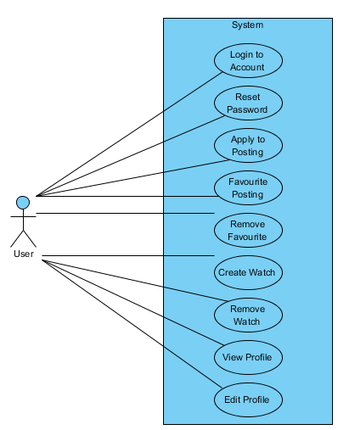

Figure : Use case diagram 1